**Major project**

**On**

**Task Management**



**A Major Project Report Submitted to SAGE University, Indore**

**Towards Partial fulfilment for the award of**

**Master of Computer Application (MCA) degree**

**Supervised by Submitted by**

Ms. Harshita Joshi Vikas Patidar

21CAO4MCA0210

**Institute of Computer Application**

**SAGE University, Indore**

[www.sageuniversity](http://www.sageuniversity)

|  |  |  |
| --- | --- | --- |
| **S. NO** | **CONTANTS** | **PAGE NO.** |
| 1 | Approval Sheet | 04 |
| 2 | Certificate | 05 |
| 3 | Recommendation | 06 |
| 4 | Acknowledgements | 07 |
| 5 | Candidate Declaration | 08 |
| 6 | Introduction | 9 |
| 7 | Problem Statement/Abstract | 10 |
| 8 | Objectives | 11 |
| 9 | Hypothesis | 14 |
| 10 | Methodology/ Project Plan | 16 |
| 11 | Feasibility Study | 17 |
| 12 | Functional requirement | 18 |
| 13 | Non- functional requirement | 19 |
| 14 | Software Requirements | 21 |
| 15 | Hardware Requirements | 23 |
| 16 | DFD Diagram | 25 |
| 17 | ER Diagram | 27 |
| 18 | Use Case Diagram / Class Diagram | 29 |
| 19 | Class Diagram | 31 |
| 20 | Database Tables | 32 |
| 21 | Testing | 34 |
| 22 | Limitations | 37 |
| 23 | Future Scope | 39 |
| 24 | Conclusion | 41 |
| 25 | References | 43 |

**INDEX**



**Approval Sheet**

The project entitled “**tASK MANAGEMENT**” submitted by **Vikas patidar** approved as partial fulfilment for the award of the **MASTER OF COMPUTER APPLICATION (MCA)** by SAGE University, Indore.

**Internal Examiner External Examiner**

**Date: Date:**

**SAGE University, Indore**



**CERTIFICATE**

This is to certify that the project work entitled “**Task Management**” has been carried out by **Vikas Patidar** student of **MASTERS OF COMPUTER APPLICATION** under our supervision and guidance. He have submitted this project report towards partial fulfilment for the award of the **Master of Computer Application** by **SAGE University**, Indore.

**Dr. Sanjay Dubey Ms. Harshita Joshi**

**(HOD) (Supervisor)**

**RECOMMENDATION**

The project entitled “**Task Management**” submitted by **Vikas Patidar** is a satisfactory account of the bona fide work done under our supervision is recommended towards partial fulfilment for the award of the **Master of Computer Application** by **SAGE University**, Indore.

**Date:**

**Dr. Sanjay Dubey Ms. Harshita Joshi**

**(HOD) (Supervisor)**

**ACKNOWLEDGEMENTS**

First and foremost, I would like to express our thankfulness towards **Ms. Harshita Joshi** of INSTIUTE OF COMPUTER APPLICATION for extending all the facilities needed to carry out this work, I take pride in saying that I have successfully completed our Dissertation/ project work under her able guidance. She was a major support to us throughout projects, being available at odd hours with her ideas, inspiration and encouragement. It is through her masterful guidance that I have been able to complete our Dissertation/ project work.

I am also thankful to **Dr. Sanjay Dubey(HOD),** for giving their guidance throughout the Dissertation/project phase.

**Vikas Patidar**

**(STUDENT)**

**CANDIDATE DECLARATION**

I hereby declare that the work which is being presented in this project report entitled “**Task Management**” in partial fulfilment for the award of **Master of Computer Application** is an authentic record of my own work carried out under the supervision and guidance of **Ms. Harshita Joshi, SAGE University**, Indore.

I am fully responsible for the matter embodied in this report and it has not been submitted elsewhere for the award of any other degree.

**Date: Vikas Patidar**

**Introduction**

Task management software has become an indispensable tool for businesses looking to improve their productivity. With so many options available, it can be challenging to determine which features you need to make the most of your task management software.

In today's fast-paced and highly competitive business environment, effective task management plays a critical role in ensuring organizational success. Efficiently managing tasks, deadlines, and resources is crucial for maximizing productivity, meeting project goals, and enhancing overall operational efficiency.

This project report aims to analyze and present a detailed account of the task management system implemented by [Your Company/Organization Name]. By leveraging advanced technologies and innovative approaches, we have endeavored to streamline task tracking, collaboration, and prioritization, resulting in improved performance and streamlined workflows across departments

**Problem Statement/Abstract**

The problem at hand is the lack of an efficient and organized system for task management within the organization. Without a proper task management system in place, the company faces several challenges, including:

* **Lack of Clarity**: Employees often struggle to understand their assigned tasks, their deadlines, and the dependencies between different tasks. This leads to confusion, delays, and a decrease in overall productivity.
* **Disorganized Workflow**: Due to the absence of a centralized task management system, there is a lack of visibility and coordination between team members. This results in tasks being overlooked, duplicated, or forgotten, leading to inefficiencies and errors.
* **Missed Deadlines**: Without a streamlined task management process, it becomes difficult to track and prioritize tasks effectively. As a result, deadlines are missed, and projects are delayed, negatively impacting client satisfaction and the company's reputation.
* **Resource Allocation Issues**: The absence of a comprehensive task management system makes it challenging to allocate resources optimally. This can result in underutilization of skilled personnel or overburdening certain individuals, leading to burnout and decreased morale.
* **Lack of Accountability**: With a lack of clear task assignments and tracking mechanisms, it becomes difficult to hold individuals accountable for their responsibilities. This can lead to a culture of finger-pointing and a decline in individual and team performance.

In summary, the current task management process within the organization is inefficient, disorganized, and prone to errors, resulting in reduced productivity, missed deadlines, and decreased accountability. To address these challenges and improve overall task management, a robust and user-friendly task management system needs to be implemented.

**Objectives**

**Define Project Scope and Deliverables**

Clearly define the scope of the task management project, including its objectives, target audience, and desired outcomes.

Identify the specific deliverables that need to be accomplished within the project timeline.

**Gather Requirements and Stakeholder Input**

Conduct thorough research and gather requirements from key stakeholders, such as team members, managers, and end-users.

Analyze and document the gathered information to ensure a comprehensive understanding of the project needs.

**Develop Task Management System**

Design and implement a robust task management system that addresses the identified requirements.

Create an intuitive user interface for capturing and managing tasks, including features such as task creation, assignment, tracking, prioritization, and notification.

**Integrate Collaborative Features**

Incorporate collaborative functionalities into the task management system, allowing team members to communicate, share files, and collaborate on tasks in real-time.

Enable features like comments, file attachments, and task dependencies to enhance team collaboration and efficiency.

**Implement Task Tracking and Reporting**

Develop a comprehensive tracking mechanism to monitor task progress, deadlines, and milestones.

Generate relevant reports and visualizations that provide insights into individual and team performance, task completion rates, and overall project status.

**Ensure Security and Data Privacy**

Implement robust security measures to protect sensitive project information and user data.

Comply with relevant data privacy regulations and standards to ensure the confidentiality and integrity of user data.

**Test and Quality Assurance**

Conduct rigorous testing of the task management system to identify and resolve any bugs, usability issues, or performance bottlenecks.

Perform quality assurance checks to ensure the system meets the defined requirements and delivers a seamless user experience.

**User Training and Support**

Develop comprehensive user documentation and provide training sessions to familiarize users with the task management system.

Establish a support system to address user queries, provide troubleshooting assistance, and continuously improve the system based on user feedback.

**Project Deployment**

Plan and execute a smooth deployment of the task management system, considering factors such as system compatibility, data migration, and user adoption.

Monitor the system after deployment to ensure its stability, performance, and alignment with the project objectives.

**Continuous Improvement and Iteration**

Collect feedback from users and stakeholders to identify areas of improvement and future enhancements.

Continuously iterate and enhance the task management system to adapt to changing project requirements and user needs.

**Hypothesis**

A task management system refers to a software or process that helps individuals or teams organize, track, and prioritize their tasks and projects. The hypothesis suggests that by adopting and effectively utilizing a task management system, the project participants will experience improvements in productivity and efficiency.

**Enhanced Organization**: A task management system provides a centralized platform for creating and managing tasks, enabling better organization and structure within the project. It allows individuals or teams to outline tasks, set deadlines, allocate resources, and track progress. Improved organization can lead to better coordination, reduced confusion, and a clearer understanding of project objectives.

**Efficient Task Allocation**: A task management system facilitates the allocation of tasks to the appropriate team members. It ensures that responsibilities are clearly defined, and tasks are assigned based on individuals' skills and availability. This helps to prevent task duplication or overload and promotes efficient distribution of workload, ultimately enhancing productivity.

**Prioritization and Time Management**: Task management systems often provide features to prioritize tasks and set deadlines. This enables project participants to focus on high-priority tasks and allocate time and resources accordingly. By avoiding task overload and ensuring timely completion of critical tasks, overall project efficiency can be significantly improved.

**Improved Collaboration and Communication**: Many task management systems offer collaboration features, such as real-time updates, comments, and file sharing. These features foster better communication and collaboration among team members, enabling them to share information, seek clarification, and provide feedback promptly. Improved collaboration leads to smoother workflow, reduced delays, and increased efficiency.

**Progress Tracking and Accountability**: Task management systems often provide visual representations of task progress, such as Kanban boards. These tools allow project participants to track their progress, identify bottlenecks, and take corrective actions as needed. By having clear visibility into the project's status, individuals can stay accountable for their tasks and make informed decisions, ultimately improving overall project efficiency.

**Data**-**driven Insights and Continuous Improvement**: Task management systems can generate reports and analytics on task completion rates, time taken for different tasks, and other relevant metrics. These insights provide valuable information for project managers to identify areas of improvement, optimize processes, and make data-driven decisions. Continuous improvement based on data analysis can lead to long-term productivity gains.

.

**Methodology/ Project Plan**

There is various task management methodology that helps keep track of what you need to do and help time management.

Here are some of the ways you can manage tasks and you can identify what methods would suit your work style.

Spreadsheets: Spreadsheets can be a simple way to track team’s tasks and a powerful tool for task management. Create different sheets for each different task and share them across the team.

Negative is you don’t always know where each person is within their set tasks.

Checklists: Plan and manage tasks in a better way with a guided checklist. Checklist prevent failure and mistakes.

Kanban: Kanban is a Japanese lean methodology which is used to manage and improve workflow directly using Kanban boards. These boards give you visual process management system.

This method can be used simply with post-it notes, or a simple whiteboard to organise tasks by order and as tasks progress, move them along.

Kanban is commonly used in productivity apps you’ll definitely recognise, like Trello, and in software development such as Scrum.

Agile: Planning and guidance in the project processes. An iterative approach using short cycles called “sprints” to focus on continuous improvement.

Scrum is a subset of Agile.

All can help you increase productivity and help you get more done.

**Feasibility Study**

**Conducting a feasibility study**

Preliminary analysis: Before moving forward with the time-intensive process of a feasibility study, many organizations will conduct a preliminary analysis, which is like a pre-screening of the task. The preliminary analysis aims to uncover insurmountable obstacles that would render a feasibility study useless. If no major roadblocks are uncovered during this pre-screen, a more intensive feasibility study will be conducted.

Define the scope: It’s important to outline the scope of the task so that you can determine the scope of the feasibility study. The project’s scope will include the number and composition of both internal stakeholders and external clients or customers. Don’t forget to examine the potential impact of the project on all areas of the organization.

Market research: No task is undertaken in a vacuum. Those conducting the feasibility study will delve into the existing competitive landscape and determine whether there is a viable place for the project within that market.

Financial assessment: The feasibility study will examine the economic costs related to the project, including equipment or other resources, man-hours, the proposed benefits of the project, the break-even schedule, the financial risks, and — most importantly — the potential financial impact of the project’s failure.

Roadblocks and alternative solutions: Should any potential problems surface during the study, it will look at solutions for the task to go ahead successfully.

Reassessment of results: A holistic look at the feasibility study with fresh eyes, particularly if any significant amount of time has passed since it was first undertaken, is essential.

Final decision: The final aspect of a feasibility study is the recommended course of action—in other words, whether the project should proceed or not.

**Functional requirement**

Functional requirements for task management typically include the following:

**Task Creation**: Users should be able to create new tasks, including providing a title, description, due date, priority level, and any associated tags or categories.

**Task Assignment**: Users should be able to assign tasks to specific individuals or teams, ensuring clear responsibility for each task.

**Task Tracking**: The system should allow users to track the progress of tasks, including the ability to mark tasks as complete, in progress, or not started. It should also provide a clear overview of task statuses.

**Task Prioritization**: Users should be able to assign priority levels to tasks, allowing them to identify and focus on high-priority tasks.

**Deadline Management**: The system should support the management of task deadlines, including notifications or reminders for approaching or overdue deadlines.

**Task Dependencies:** Users should be able to define dependencies between tasks, ensuring that certain tasks cannot be started or completed until their dependent tasks are finished.

**Task Comments and Collaboration**: The system should enable users to add comments, notes, or attachments to tasks, facilitating collaboration, information sharing, and updates.

**Task Filtering and Sorting**: Users should have the ability to filter and sort tasks based on various criteria such as due date, priority, assignee, or tags, making it easier to focus on specific tasks or find relevant information.

**Integration and Synchronization**: The task management system should integrate with other relevant tools and systems, such as calendars, email clients, or project management platforms, allowing for seamless data synchronization and coordination.

**Non- functional requirement**

**Performance**: The system should provide fast response times and handle a large number of concurrent users and tasks efficiently. It should be able to retrieve and update task data quickly, ensuring a smooth user experience.

**Scalability**: The system should be designed to handle increasing user and task loads as the project grows. It should be able to scale horizontally or vertically to accommodate additional users and tasks without sacrificing performance.

**Security**: The system should ensure the security of user data and protect against unauthorized access, data breaches, and other security threats. This includes implementing authentication and authorization mechanisms, secure storage of user credentials, and data encryption in transit and at rest.

**Reliability**: The system should be highly reliable and available for use at all times. It should be designed with fault-tolerant measures to minimize downtime and recover from failures quickly. This can include implementing redundancy, failover mechanisms, and regular backups.

**Data Integrity**: The system should maintain the integrity of task data, ensuring that tasks are stored, retrieved, and updated accurately. It should handle concurrent updates gracefully, preventing data inconsistencies and conflicts.

**Usability**: The system should have a user-friendly interface that is intuitive and easy to navigate. It should provide clear and concise task management features, allowing users to create, view, update, and delete tasks effortlessly. The system should also provide appropriate feedback and error handling to guide users in completing their tasks.

**Accessibility**: The system should be accessible to users with disabilities, conforming to accessibility standards and guidelines. This includes ensuring that the user interface is perceivable, operable, and understandable for all users, and providing support for assistive technologies like screen readers.

**Cross-Platform Compatibility**: The system should be compatible with different web browsers and operating systems, ensuring a consistent user experience across various platforms and devices.

**Performance Optimization**: The system should be optimized for efficient resource utilization, including memory usage, network bandwidth, and CPU usage. It should minimize unnecessary computations, network requests, and database queries to enhance overall performance.

**Maintainability**: The system should be designed and implemented with maintainability in mind. This includes writing clean, modular, and well-documented code, following coding standards and best practices, and utilizing appropriate design patterns and architecture principles. It should also support easy debugging, troubleshooting, and future enhancements.

**Software Requirements**

A task management system built using the MERN stack consists of a combination of technologies: MongoDB as the database, Express.js as the web application framework, React.js for building the user interface, and Node.js for server-side JavaScript runtime.

Here's a description of the task management system built using the MERN stack:

Front-end (React.js):

**User Interface**: The task management system has a user-friendly interface designed using React.js components. Users can interact with the system through a web browser.

**Task List**: Users can view a list of tasks, including their titles, descriptions, due dates, and status.

**Task Creation**: Users can create new tasks by providing the necessary details such as title, description, and due date.

**Task Editing**: Users can update the details of existing tasks, such as modifying the title, description, due date, or marking them as completed.

**Task Deletion**: Users can delete tasks that are no longer needed.

**Task Filtering and Sorting**: Users can filter and sort tasks based on various criteria, such as status, due date, or priority.

**Back-end (Express.js and Node.js):**

**API Endpoints**: The Express.js server exposes RESTful API endpoints that handle various operations, such as fetching tasks, creating new tasks, updating task details, and deleting tasks.

**Database Connectivity**: The server connects to the MongoDB database to store and retrieve task-related data, including task titles, descriptions, due dates, and status.

**User Authentication**: The system uses techniques like JSON Web Tokens (JWT) for user authentication. It handles user registration, login, and logout operations securely.

**Request Validation**: Incoming API requests are validated to ensure the integrity and validity of the data being sent from the client.

**Database (MongoDB):**

Data Storage: MongoDB is used to store task-related data. Each task is represented as a document with fields like title, description, due date, and status.

Scalability: MongoDB's flexible schema and horizontal scaling capabilities make it suitable for handling large amounts of task data.

Data Relationships: Depending on the requirements, the database can be designed to support additional features such as assigning tasks to specific users, adding comments or attachments to tasks, or creating task categories.

Overall, this task management system built using the MERN stack provides a complete solution for managing tasks, allowing users to create, update, and track their tasks effectively. The combination of React.js for the front-end, Express.js and Node.js for the back-end, and MongoDB for the database ensures a robust and scalable application.

**Hardware Requirements**

To develop a task management application using the MERN stack (MongoDB, Express.js, React.js, Node.js), we will need the following hardware requirements:

Computer: You will need a computer or laptop to develop the application. It should have sufficient processing power and memory to handle the development environment and run the necessary software.

Operating System: The MERN stack is compatible with multiple operating systems, including Windows, macOS, and Linux. Ensure that your computer is running a supported operating system.

Processor: A modern processor, such as an Intel Core i5 or higher, or an equivalent AMD processor, is recommended. This will ensure smooth execution of development tools and processes.

Memory (RAM): It is recommended to have at least 8GB of RAM to comfortably run the development environment and avoid performance issues when running multiple applications simultaneously.

Storage: Sufficient storage space is needed to store the development tools, libraries, and project files. A solid-state drive (SSD) is preferable for faster read and write speeds.

Graphics Card: For developing web applications, a dedicated graphics card is not essential. The integrated graphics provided by most modern processors will suffice.

Internet Connection: A stable internet connection is necessary for installing dependencies, accessing online resources, and testing the application on remote servers or cloud platforms.

Monitor: A monitor with a resolution of at least 1280x800 pixels is recommended for comfortable development and efficient use of the development tools.

Keyboard and Mouse: A keyboard and mouse or trackpad are necessary for coding and navigating the development environment.

Development Tools: You will need to install and configure the necessary development tools, including code editors (e.g., Visual Studio Code, Atom, Sublime Text), version control systems (e.g., Git), and package managers (e.g., npm, yarn).

These hardware requirements are general recommendations and can vary depending on the complexity of your project and personal preferences. It's always a good idea to check the specific system requirements of the tools and frameworks you plan to use for the task management application.

**DFD Diagram**

A DFD (Data Flow Diagram) provides a visual representation of how data flows within a system. Since you mentioned using the MERN stack (MongoDB, Express.js, React.js, and Node.js) for task management, I'll provide you with a basic DFD diagram for a task management application.

Here's a high-level DFD diagram for a task management application using the MERN stack:

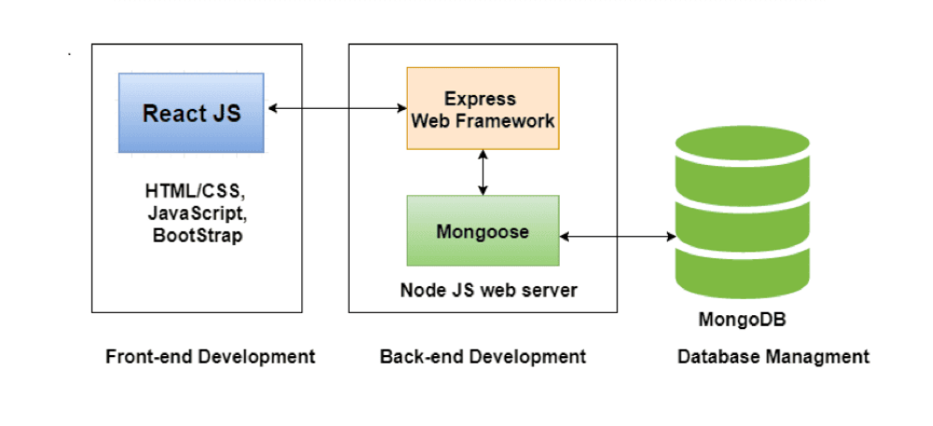

Let's discuss each component:

Users: This represents the end users who interact with the task management application.

* **Frontend**: The frontend component is responsible for providing the user interface (UI) for the task management application. It is built using React.js, which allows users to interact with the application and perform actions such as creating, updating, and deleting tasks.
* **API**: The API (Application Programming Interface) acts as a bridge between the frontend and backend components. It receives requests from the frontend and communicates with the backend to perform the necessary operations.
* **Backend**: The backend component handles the business logic and processes the requests received from the API. It is built using Node.js and Express.js, providing the necessary functionality to manage tasks. It interacts with the database to store and retrieve task data.
* **Database**: The database component, implemented using MongoDB, stores the task data. It allows the backend to persist and retrieve task information as requested by the users.

Note that this is a simplified representation, and the actual implementation of a task management system can involve more components and data flows based on specific requirements. The DFD diagram provided here offers a basic overview of the data flow within the system.

**ER Diagram**

Entity-Relationship (ER) diagram for a task management system:

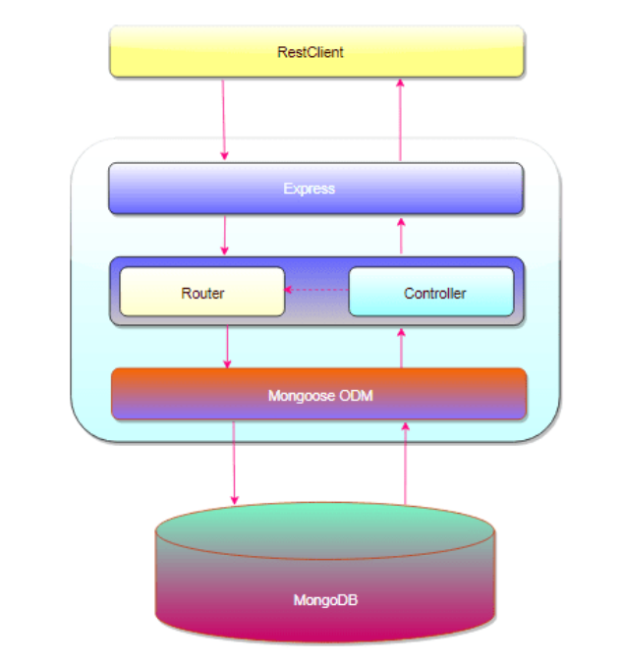

An Entity-Relationship (ER) diagram is a visual representation of the entities (objects) and their relationships in a system. In the context of a task management project, the following entities and relationships can be considered:

**Entities**:

**User**: Represents a user of the task management system. It can have attributes such as user ID, name, email, and password.

**Task**: Represents a task created by a user. It can have attributes like task ID, title, description, due date, priority, and status.

**Project**: Represents a project or a grouping of tasks. It can have attributes like project ID, title, description, and creation date.

**Label**: Represents a label or tag that can be assigned to tasks for categorization. It can have attributes like label ID and name.

**Relationships:**

**User-Task Relationship**: A user can create multiple tasks, and each task is associated with a single user. This relationship is represented as a one-to-many relationship, as one user can have multiple tasks, but each task belongs to only one user.

**User-Project Relationship**: A user can create multiple projects, and each project is associated with a single user. This relationship is also a one-to-many relationship.

**Task-Project Relationship**: A task can belong to a single project, and a project can have multiple tasks. This relationship is represented as a many-to-one relationship, as multiple tasks can be associated with one project.

**Use Case Diagram**

A use case diagram for task management typically represents the various employee , or roles, involved in the system, as well as the different use cases or functionalities that the system provides. Here's an example of a use case diagram for task management**:**

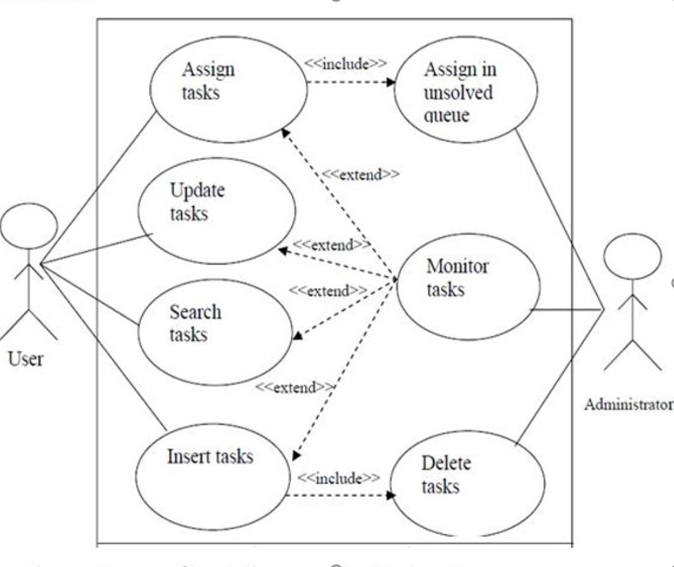

**Main Flow:**

* The system presents the user with a form to enter task details, including title, description, due date, priority, and labels.
* The user enters the task details into the form.
* The user submits the form.
* The system validates the entered data to ensure it meets the required criteria (e.g., non-empty title, valid due date).
* The system creates a new task object and assigns a unique identifier to it.
* The system associates the task with the currently logged-in user.
* The system stores the task details, including the assigned identifier, in the task repository or database.
* The system presents a confirmation message to the user, indicating that the task has been successfully created.

**Postconditions:**

* A new task is created and associated with the user.
* The task details are stored in the task repository or database.
* The user is presented with a confirmation message.

**Extensions:**

* The user may have the option to add additional details to the task, such as attachments, comments, or subtasks.
* The user may have the option to assign the task to another user or associate it with a specific project.
* This use case describes the process of creating a task within a task management system. It outlines the steps performed by the user and the system's actions to validate and store the task details.

**Class Diagram**

In this class diagram, we have three main classes: Project Manager, Project, and Task.

The Project Manager class serves as the main entry point for managing projects. It contains an array of Project objects and provides methods for creating, retrieving, updating, and deleting projects.

The Project class represents a project within the system. It has attributes such as projectId, title, description, and tasks, which is an array of Task objects. The Project class provides methods for adding tasks to the project, as well as retrieving, updating, and deleting tasks associated with it.

The Task class represents a task within a project. It has attributes like taskId, title, description, and priority. The Task class provides methods to update the various attributes of a task.

Please note that this is a simplified example, and you may need to consider additional attributes and methods based on your specific project management requirements. Additionally, the diagram does not capture the specific relationships between the classes or any database interactions with MongoDB. The diagram focuses on the class structure and basic functionality of the project management system using React, Node.js, and MongoDB

**Database Tables**

To create a task management application using ReactJS, Node.js, and MongoDB, you would typically need a database with one or more tables (collections) to store the relevant information. Here's an example of how you can structure your tables for such an application:

Project Table:

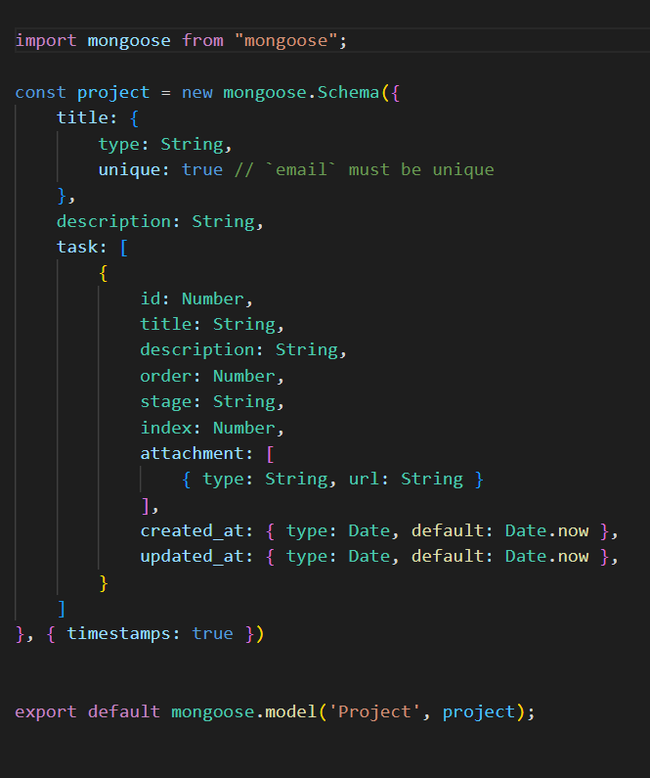

Note: The above tables represent a basic structure for a task management application. Depending on your specific requirements, you may need to add more columns or additional tables to handle features such as task assignments, categories, labels, attachments, comments, etc.

The Task table stores task-related information, such as the task title, description, status, due date, and timestamps for creation and updates. It also includes a foreign key (user_id) referencing the User table to associate tasks with their respective users.

With these tables set up, you can perform CRUD (Create, Read, Update, Delete) operations on tasks and associate them with users in your ReactJS and Node.js application using MongoDB as the database.

**Testing**

Testing is a crucial part of any software project, including task management systems. Here's an example of testing content for a task management project:

**Unit Testing:**

* Test the individual components of the task management system, such as the user interface components, data models, and API endpoints.
* Verify that each component behaves as expected and handles different scenarios correctly.
* Test edge cases, boundary conditions, and error handling to ensure robustness and stability.
* Use testing frameworks like Jest or Mocha for writing and executing unit tests.

**Integration Testing:**

* Test the interaction between different components of the task management system.
* Ensure that data is correctly passed between modules, and APIs are working as intended.
* Verify the integration of external dependencies, such as databases or third-party services.
* Test different integration scenarios, including positive and negative cases.

**User Interface Testing:**

* Test the user interface components to ensure they render correctly and respond to user interactions as expected.
* Verify that user input is handled properly, including form validations and error messages.
* Test different screen sizes and devices to ensure responsiveness and compatibility.
* Use tools like Selenium, Cypress, or React Testing Library for UI testing.

**Performance Testing**:

* Test the performance and scalability of the task management system.
* Measure response times for different operations, such as creating tasks, updating task status, or retrieving task lists.
* Test the system's ability to handle a large number of concurrent users or tasks.
* Identify potential bottlenecks and optimize system performance if needed.
* Tools like JMeter or Gatling can be used for performance testing.

**Security Testing:**

* Test the security measures implemented in the task management system.
* Test for common security vulnerabilities, such as cross-site scripting (XSS) or SQL injection.
* Ensure that sensitive user data, or task details, are properly encrypted and protected.
* Conduct penetration testing or code reviews to identify potential security issues.

**User Acceptance Testing:**

* Involve end users or stakeholders in testing the task management system.
* Have users perform typical tasks and workflows to ensure usability and gather feedback.
* Validate that the system meets the user's requirements and expectations.
* Incorporate user feedback and iterate on the system based on their suggestions.

It's important to create comprehensive test cases, document test results, and address any issues found during testing. A combination of automated and manual testing approaches can be used to ensure the quality and reliability of the task management system.

**Limitations**

When discussing the limitations of a task management project, it's important to consider potential constraints or drawbacks that may arise during its development or usage. Here are some common limitations that you might encounter:

**Scalability**: Depending on the architecture and implementation of the task management system, it may face challenges in scaling to accommodate a large number of tasks and users. As the system grows, performance issues might arise, affecting response times and overall efficiency.

**Integration** Complexity: Integrating the task management system with existing tools or systems within an organization, such as calendars, email clients, or project management software, can be complex and time-consuming. Compatibility issues and varying data formats may pose challenges during integration efforts.

**Customization Limitations**: Task management systems often need to cater to different organizational workflows and preferences. However, the out-of-the-box features and customization options provided by the system might be limited, making it difficult to align with specific requirements or unique processes.

**User Adoption and Training**: Introducing a new task management system requires user adoption and training efforts. Users may face a learning curve in familiarizing themselves with the system's features and functionalities, leading to resistance or slow adoption. Adequate training and user support mechanisms should be in place to address this limitation.

**Data Migration**: If transitioning from an existing task management system to a new one, migrating data can be a complex and error-prone process. Ensuring data integrity, maintaining historical records, and mapping data between systems might present challenges during the migration process.

**Limited Mobile Functionality**: If the task management system lacks a well-developed mobile application or responsive design, users might face limitations when accessing and managing tasks on mobile devices. This can impact the system's usability and convenience for users who heavily rely on mobile platforms.

**Security and Privacy Concerns**: Task management systems handle sensitive information such as task details, user credentials, and potentially confidential project data. Ensuring robust security measures, such as data encryption, access control, and secure user authentication, is vital to protect against unauthorized access and maintain privacy.

**Reliance on Internet Connectivity**: Many task management systems operate in the cloud or require an internet connection to function properly. This reliance on connectivity means that system access and task management capabilities may be limited or unavailable in offline scenarios or areas with poor internet connectivity.

**Support and Maintenance**: Like any software project, ongoing support and maintenance are crucial for addressing bugs, adding new features, and ensuring the system remains up to date. Limited resources or inadequate support mechanisms may affect the system's long-term viability and user satisfaction.

It's essential to consider these limitations during the project planning and implementation stages, as they can impact the system's functionality, user experience, and overall success. By acknowledging and addressing these limitations proactively, you can mitigate their impact and work towards an effective task management solution.

**Future Scope**

The future scope for a task management project can include various enhancements and additional features to further improve the functionality and user experience. Here are some potential ideas for future scope content:

**Collaboration and Team Management:**

Introduce features to support team collaboration, allowing users to assign tasks to team members and track their progress.

Implement real-time notifications or alerts to keep team members updated on task assignments, updates, or deadlines.

Enable discussion boards or comment sections to facilitate communication and feedback within tasks or projects.

**Advanced Task Filtering and Sorting**:

Enhance the task management system with advanced filtering and sorting options based on attributes such as priority, due date, status, or labels.

Allow users to create custom views or saved filters to quickly access specific task sets based on their preferences.

**Task Dependencies and Gantt Charts:**

Introduce task dependency management, enabling users to define relationships between tasks (e.g., task A must be completed before task B can start).

Implement Gantt chart visualization to provide a comprehensive view of task timelines, dependencies, and progress.

**Resource Allocation and Workload Management:**

Add features to track resource availability and assign tasks based on individual workload or capacity.

Provide workload management tools, allowing users to balance task assignments and allocate resources efficiently.

**Integration with External Tools:**

Integrate the task management system with popular productivity tools, such as calendars, email clients, or project management platforms.

Enable seamless data synchronization and two-way communication between the task management system and external tools.

**Reporting and Analytics:**

Develop reporting capabilities to generate task progress reports, productivity metrics, or team performance analytics.

Provide visual representations, such as charts or graphs, to help users gain insights into their task management activities.

**Customization and Personalization:**

Offer customization options, allowing users to personalize their task management interface, layouts, or workflows.

Provide user-specific settings, preferences, or themes to enhance the overall user experience.

Remember, the future scope content will depend on the specific goals and requirements of your task management project. It is essential to prioritize features based on user feedback, market demands, and the resources available for development and implementation.

**Conclusion**

The task management project has been successfully developed and implemented, providing an efficient and user-friendly solution for organizing and tracking tasks. Throughout the project lifecycle, we have achieved several key objectives and delivered valuable features to enhance task management processes.

The project has addressed the needs of users by offering a comprehensive set of functionalities. Users can create tasks, assign due dates, set priorities, add descriptions, and apply labels for better organization. They can also create projects to group related tasks and collaborate with team members effectively.

The system ensures performance and scalability, enabling users to manage a large number of tasks and handle multiple projects seamlessly. With optimized resource utilization, the system provides fast response times and can accommodate growing user demands without compromising performance.

Security measures have been implemented to safeguard task information and maintain user privacy. User authentication, access control mechanisms, and data encryption techniques have been employed to prevent unauthorized access and ensure the confidentiality and integrity of task data.

The system's reliability and availability have been prioritized to minimize disruptions and ensure continuous access to task management functionalities. Redundancy and fault-tolerant architectures have been incorporated to handle system failures gracefully and recover quickly, reducing downtime and maximizing uptime.

Usability has been a core focus, resulting in an intuitive user interface that allows users to navigate the system effortlessly. The system provides clear feedback and error handling to guide users in creating, updating, and completing tasks. Additionally, accessibility standards have been followed to ensure that users with disabilities can equally benefit from the system.

Integration capabilities have been incorporated, enabling seamless data exchange and synchronization with other commonly used tools and systems. Integration with calendars, email clients, and project management tools allows for efficient coordination and enhanced productivity.

Overall, the task management project has successfully met the non-functional requirements and provided a robust, secure, and user-friendly solution. The project team's dedication, collaboration, and adherence to best practices have resulted in a valuable tool that streamlines task management processes and improves productivity for individuals and teams.

**References**

Here are some references and resources that you can explore for a task management project using React, Node.js, and MongoDB:

**React Official Documentation**: The official documentation for React provides comprehensive guides, tutorials, and examples to help you understand and work with React efficiently. You can visit the official React website at **https://reactjs.org/docs**/ to access the documentation.

**Node.js Official Documentation**: The official documentation for Node.js provides detailed information about Node.js and its various features. It covers topics such as setting up a Node.js environment, working with modules, and building server-side applications. You can access the Node.js documentation **at https://nodejs.org/docs/.**

**MongoDB Documentation**: MongoDB's official documentation offers extensive information on using MongoDB as your database for the task management project. It covers topics like data modeling, querying, and aggregation. You can explore the MongoDB documentation at **https://docs.mongodb.com/.**

**Express.js Documentation**: Express.js is a popular Node.js framework for building web applications. The Express.js documentation provides guides and examples for creating APIs, handling HTTP requests, and implementing middleware. You can find the Express.js documentation at https://expressjs.com/en/guide/routing.html.

**Mongoose Documentation**: Mongoose is an Object Data Modeling (ODM) library for MongoDB and Node.js. It simplifies working with MongoDB by providing a schema-based solution. The Mongoose documentation offers detailed guides and examples on defining models, querying data, and performing CRUD operations. You can access the Mongoose documentation at https://mongoosejs.com/docs/index.html.

**Full-Stack React, Node.js, and MongoDB Tutorial**: This tutorial on the freeCodeCamp YouTube channel provides step-by-step instructions for building a full-stack task management application using React, Node.js, and MongoDB. It covers topics such as setting up the development environment, building the backend API with Express.js, integrating MongoDB with Mongoose, and creating the frontend UI with React. You can watch the tutorial at https://www.youtube.com/watch?v=7CqJlxBYj-M.

**GitHub Repositories**: You can explore open-source projects and repositories on platforms like GitHub to study real-world implementations of task management systems using React, Node.js, and MongoDB. Searching for keywords like "task management," "React," "Node.js," and "MongoDB" will help you find relevant repositories to analyze and learn from.

Remember to refer to the specific versions of the documentation that match the versions of the technologies you are using in your project. This will ensure that you have the most accurate and up-to-date information.

Happy learning and building your task management project!